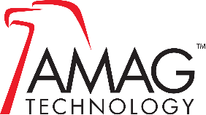


AMAG RETURN MATERIAL AUTHORIZATION (RMA) POLICY

A RMA request can be classified in one of the following categories:

1. In-Warranty Replacement - To request an RMA, please contact the Technical Support Team who will troubleshoot the issue, document the failure, and assign an AMAG RMA Number. AMAG will then ship replacement parts for these In-Warranty products.

● 1 800-874-1091, Option 2 for the Technical Support Team ● Email: technical.support@amag.com

2. Return for Credit - AMAG will accept returned products for credit if the product is in new condition, unopened and in its original packaging. All returns must be made within 90 days of the purchase date and will be subject to a 40% restock fee. For more process information, please contact the relevant customer service team:

● Orders@AMAG.com for the US Customer Services Team
● Globalorders@AMAG.com for the International Customer Services Team

Additional information:

● AMAG does not provide a repair service.
● AMAG has extended our in-warranty/replacement policy from 2 years to 5 years.
● Custom programmed units, “MTO”, or credentials cannot be returned. No exceptions.
● Third party products are subject to suppliers return policies. If the supplier agrees on the return, the customer will be held to their policies and restocking fees.
● Third party products returned with no fault found may incur an evaluation fee. In addition the unit/s may be returned to the requestor at their expense with no credit owed.
● All return for credit RMA numbers are valid for 30 days.
● Additional information regarding AMAG product warranties and policies can be found in the AMAG Certified Reseller Agreement.

RMA POLICY/MARCH 2026

www.amag.com

